**MAIN STREET**

**Overview**

Main Street is the result of a collaborative project between the DX Lab at the State Library of NSW, and the Tweed Regional Museum. It is the result of a two week ‘digital drop-in’ <http://dxlab.sl.nsw.gov.au/digital-drop-in/> program run by the Lab that supports creative and innovative thinking and is open to collaborations with staff, researchers, students, artists and digital peers.

Erika Taylor, Curator of the Tweed Regional Museum, worked with Lab developers for two weeks, to develop the concept and resulting first iteration of Main Street.

The project explored how the collection at the State Library of NSW could be used in conjunction with a NSW regional collection, to provide a beautiful digital experience that explored both collections comparatively.

Main Street uses a selection of images of “Main Streets” from the Tweed Regional Museum Collection (running on top of the page) and compares them to a set of images of “Sydney Main Streets” from the SLNSW Collection (bottom of page). The data sets are organised in sequential order ranging from the 1880s to 1950s. The middle of the page shows common words from newspapers of that year, the Sydney Morning Herald and the Tweed Daily.

The project uses several cultural heritage API’s, the project documentation, and resulting code, will be made freely available shortly.

*This project is supported by Arts NSW’s Mentorship, Fellowship and Volunteer Placement Program; a devolved funding program administered by Museums and Galleries NSW on behalf of the NSW Government.*

**Brainstorm**

Initial brainstorming for the project began a few weeks before arriving at the SLNSW. Erika pitched a few initial ideas to Paula Bray and Richard Neville, Mitchell Librarian, via Skype. The most favorable idea was one that used the State Library of NSW collection to give context to a regional collection.

On arrival at the SLNSW the DX lab and Erika workshopped the idea, evolving the project to specifically look at images of “Main Streets” making a visual comparison over time. Initial ideas were to compare George St in Sydney to regional town main street, but Library Senior curator Louise Denoon reminded us of the bias that may bring to the project. The idea to include some of Sydney’s earliest suburbs would provide a deeper look over a wider spread of demographics and area. In 1911, census figures reveal that more than a third of people living in the metropolis still resided in the City of Sydney and its adjoining suburbs within walking distance – [Glebe,](http://dictionaryofsydney.org/place/glebe)[Newtown,](http://dictionaryofsydney.org/place/newtown)[Redfern,](http://dictionaryofsydney.org/place/redfern)[Paddington,](http://dictionaryofsydney.org/place/paddington)[Erskineville](http://dictionaryofsydney.org/place/erskineville) and [Waterloo.](http://dictionaryofsydney.org/place/waterloo) [1]. Thus those suburbs and their main street used in the comparison included as “Sydney”.

The idea of “Main Street’ in the TRM collection was also to cover a large geographical area of several towns and Main streets.

During the brainstorming phase several data sets and API’s were suggested as being used: eHive API, State Library of NSW API, National Library of Australia’s TROVE API, Australian Bureau of Statistics API.

**Data**

The Tweed Regional Museum collection data

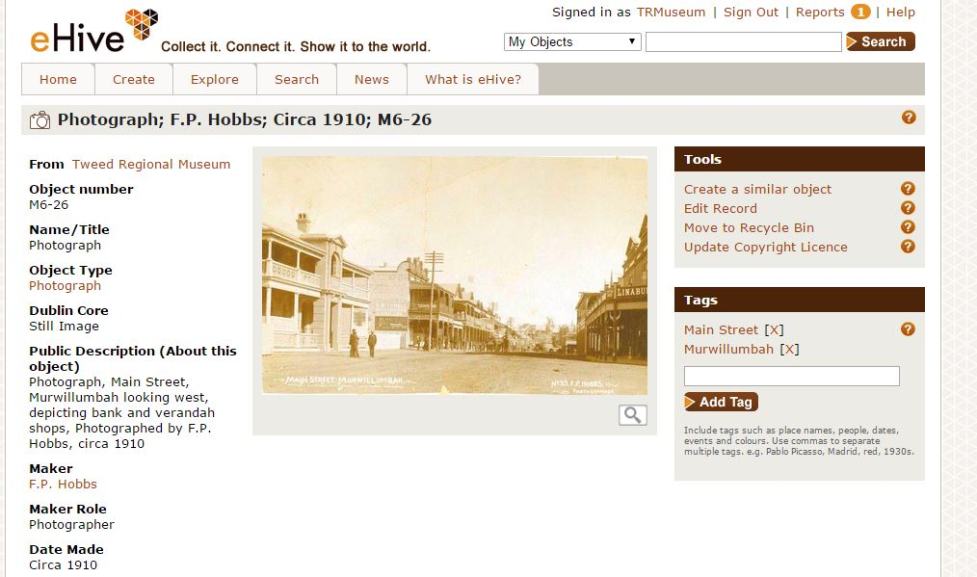

The TRM uses online cataloguing platform eHive <https://ehive.com/account/5051> to publish their collection online. eHive provides an API <http://developers.ehive.com/> which can be used to access data.

243 images of “Main Streets” were tagged as such in the TRM’s collection. The API was then used to integrate these into the project.

The resulting data set was curated down to 104 images.

The State Library of NSW collection data <http://www.acmssearch.sl.nsw.gov.au/s/search.html?collection=slnsw>

eral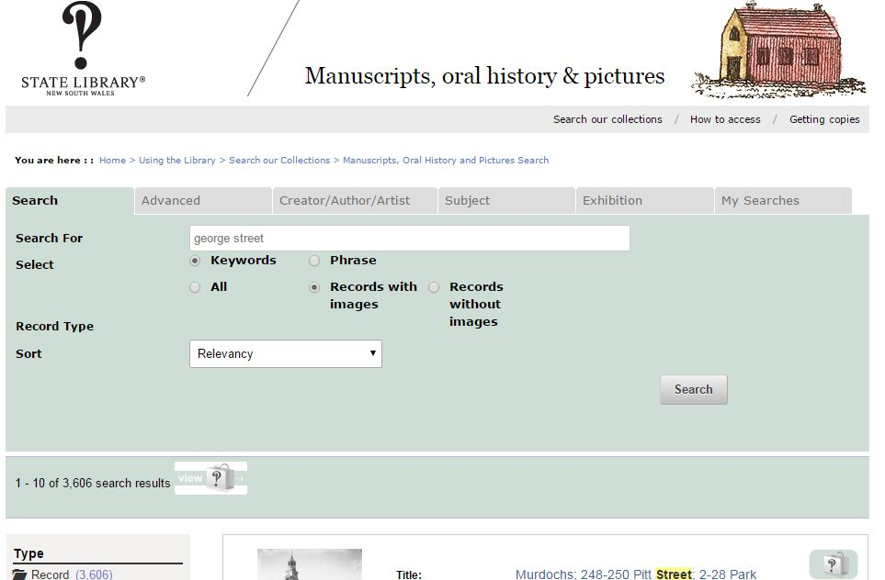

A list of 100 images was curated by Erika Taylor from the SLNSW collection. This was organised in excel and provided to web developer to be used in the project.

The images were chosen from several of Sydney City’s main streets, and surrounding suburbs. Images of transport, people, activities,

TROVE http://trove.nla.gov.au/

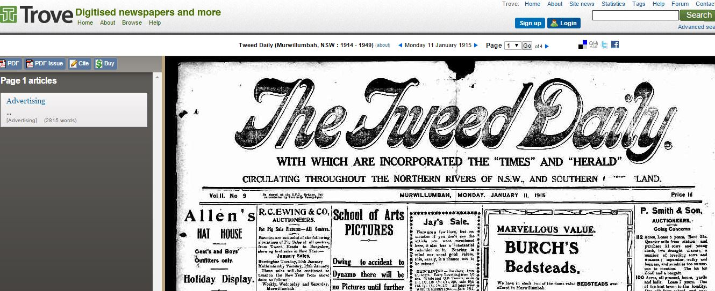

Headlines from the Sydney Morning Herald and The Tweed Daily were used in the project. These were gathered from TROVE using the API

**Look and Feel**

UX developer Ruth presented an initial look and feel that using vertical scrolling images comparing city and country main streets with TROVE data integrated

|  |  |  |
| --- | --- | --- |
| C:\Users\etaylor\Desktop\7.jpg | C:\Users\etaylor\Desktop\3.jpg | C:\Users\etaylor\Desktop\2.jpg |

This idea was refined further with inspiration from the “On Broadway” data visualisation interactive installed in the New York Public Library in 2013 http://www.on-broadway.nyc/. The idea to work in the horizontal access was adopted, which provided a visual “main street” into the project.

|  |
| --- |
| **C:\Users\etaylor\Desktop\6.JPG** |

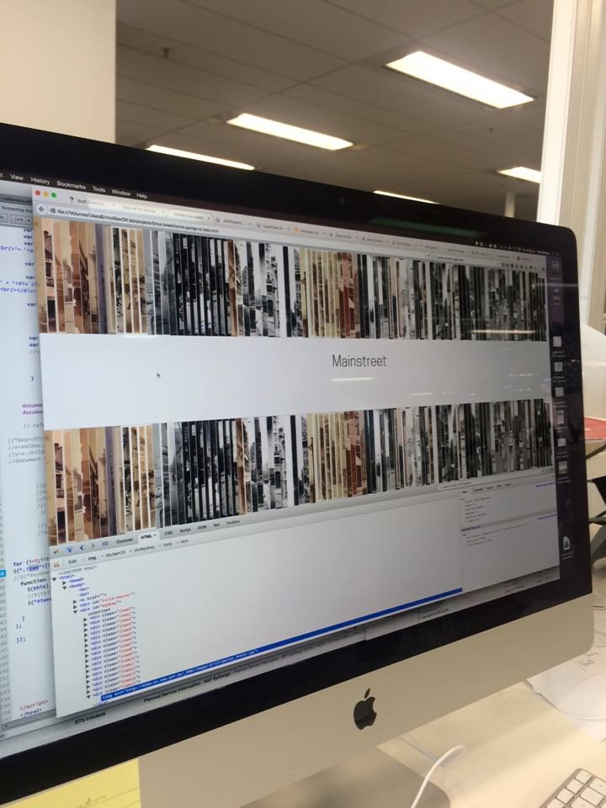

**Issues**

* Dirty data. A full day was used cleaning up the TRM data in ehive, which included tidying up descriptions, dates and date ranges, and finer cropping of images. The SLNSW online collection data proved too dirty and too large to enable the use of the API in the project. It was decided that a better result, for such a small project, was to hand curate a data set of 100 “Main Street” images from the SLNSW collection. While this a little time consuming, the end result is much better for it. Date formats! So many, so little time.
* The prolific use of “circa” and wide date ranges in both sets of collection data made using the exact dates, or matching any exact dates difficult. Instead a more fluid approach was taken to dates and images placed in chronological order. It was also important to realise that while many images of Sydney exist in the late 1800s, it would be rare to find many in regional collections. As a result a lower date cut off of around 1880 was used, and a upper range of 1950 was used.
* The project team would have liked to integrate a few bits of statistical data from the ABS, such as migration rates, population figures, however time restraints prohibited the investigation of this.

**Main Street of the future**

More regional collection data could be imported into MainStreet quite easily. EHive has been a fabulous tool for the TRM to publish their collection online, is user friendly, and cost effective, however future data sets of 104 from regional collections could be provided in a simple excel spreadsheet with jpegs.

**Tips for regional museums to curator a data set**

1. Use the example excel document
2. Fill it in for your collection, you will need 104 entries.
3. In the “Image URL” column, if you don’t have your collection online then prepare a folder on your computer of images. In the excel column paste the name of the file so the SLNSW can match the two. Use jpegs of good quality, the size preferred is ???
4. Organise your spreadsheet buy year. Just use the year in the date column, as no specific dates are used in the project, just a range, we only need to be able to arrange all you data by the year.
5. Try and include aerial views of main streets, shops, parades, things happening in main streets, and a spread of dates from 1880 to 1950. Make sure the images you use are high quality and cropped neatly. Don’t choose images that are panoramic, or extreme portrait format. The Images from the existing collections in landscape format.

1. http://dictionaryofsydney.org/entry/suburban_sydney